**Chapter IV**

**PRESENTATION, ANALYSIS AND INTERPRETATION**

This chapter will discuss the presentation, analysis, and interpretation of data corresponding to the research study stated at the beginning of the study. All the graphs, studies and other data that provides the study to strengthen the ideas below.

**4.1 Developing the Existing System to the Proposed System**

**Context Diagram of the Proposed System**

The proposed system has 3 users: First, administrator for the distributing, monitoring the reports and transaction. Secondly, customers for the ordering, transaction, and contacting the developers. Lastly, agent for the updating of the product if they have a new product, and they can monitor the product and the order of the customer. The system can enhance in terms of payment, geographical location of the customer, less security provision and the accurateness of the product management. The diagram below shows the context diagram of the proposed system.



*Figure 4.1: Context Diagram of the Proposed System*

**Project Development Process**

The proponents use Waterfall model as a guide to the fulfillment of the project. The diagram below shows the systematic procedure that proponents followed.

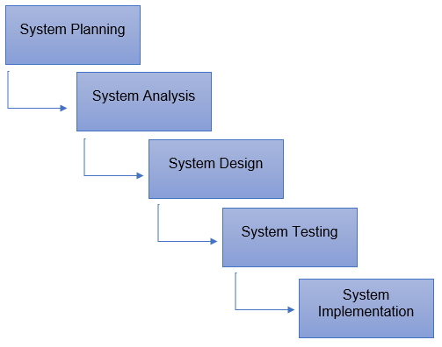

*Figure 4.2: Project Development Process*

**System Planning and Analysis.**

In this phase, the proponents gathered data that needed in their systems like software requirements, hardware requirements and the idea in terms of e-commerce. They analyzed the solution of the gathered data of the proposed system. Before the proponents start the actual coding, they need to understand the requirements of the client-side design and user, and the finished product looks like.

**System Design**

After the planning and analyzing part, the design helps in indicating software and hardware requirements, and it helps the overall system planning. The proponents study an UI/UX for the better graphical user interface. They create an algorithm to make Management System for Food E-Commerce with PayPal Integration and Database Algorithm run faster in different web browser.

**System Testing and Implementation**

The work split in different modules and the actual coding must start. The small part is called modules, modules are tested and developed for its functionality. And integrated all modules to the implementation. The proponents test their system in hard ways like security, files accessing, a bunch of data, simultaneously use of website, text field expression and image upload. And in the implementation, they upload the website and template to the web server. They make their website more accessible.

**Flowchart**

The flowchart below illustrates the sequential order of a process needed to perform by the proponents. Each step in the sequential order is recognized within diagram shape. Sequential order is associated with connecting lines with directional arrows. This allows everyone to prospect the entire flowchart of the proposed system.









































*Figure 4.3: Flowchart*

**4.2 Project Structure**

**HIPO Chart (Hierarchy plus Input-Process-Output)**

The illustrations below show the entire blueprint of the system including the hierarchy chart that strongly represents the system’s control structure and screenshots of every page of the website.





















*Figure 4.4: HIPO Chart (Hierarchy plus Input-Process-Output)*

**Screenshots**

The Home page can show the templates online and food e-commerce. Templates online, where the templates are already rented, while in food e-commerce templates are available for rented by the client.

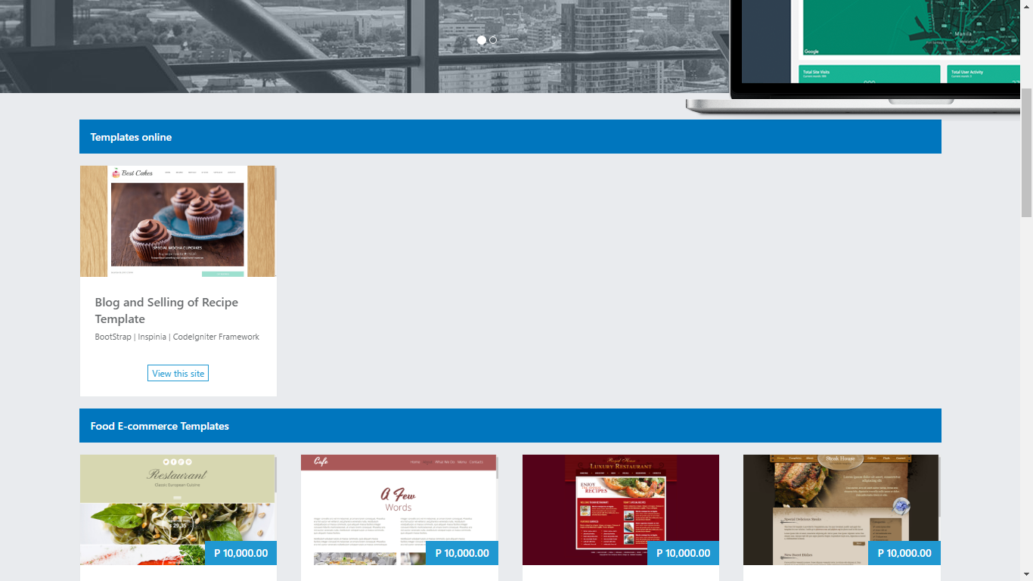

*Figure 4.5: Home Page*

The thoughts of the administrator are all posted at Blog section. Before the user allowed to comment it, he/she needs to log in his/her account.

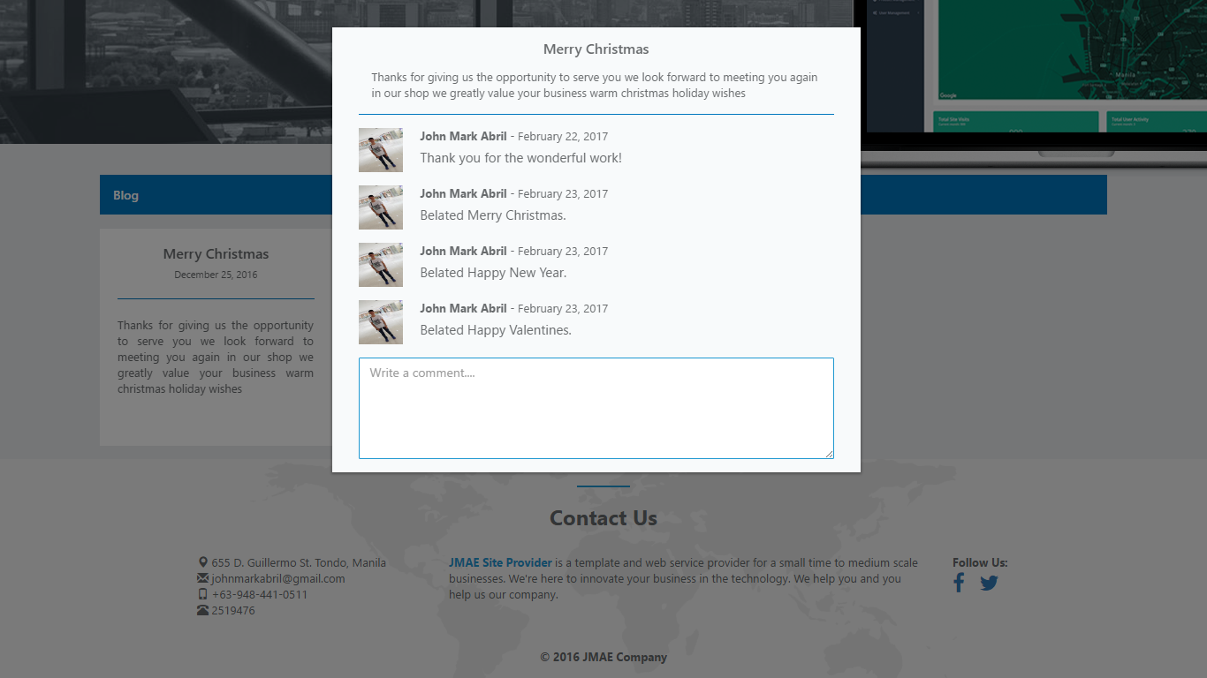

*Figure 4.6: Blog*

The upcoming events and updates of the company are all posted at Events section. The users need to log in his/her account before he/she allowed to comment it.

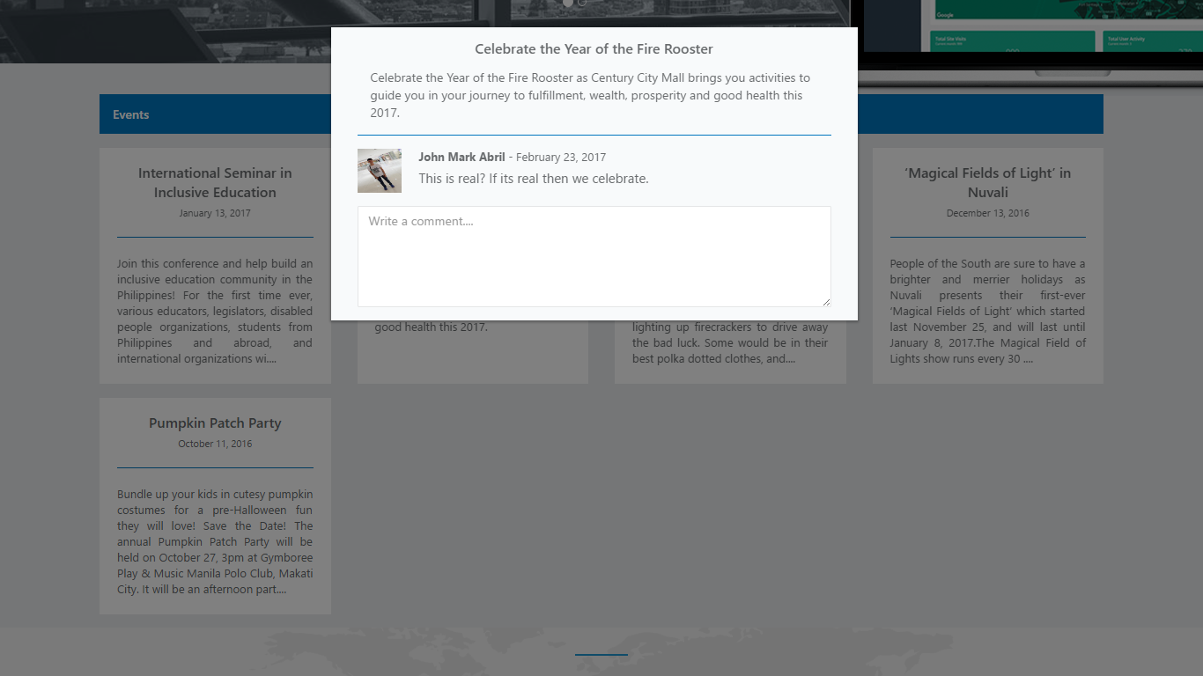

*Figure 4.7: Events*

In Testimonials section, the feedback of the client for the services given by the JMAE Site Provider are posted in this section.



*Figure 4.8: Testimonials*

The login form is a progress by which the user is allowing to access the website by identifying his/her username and password.

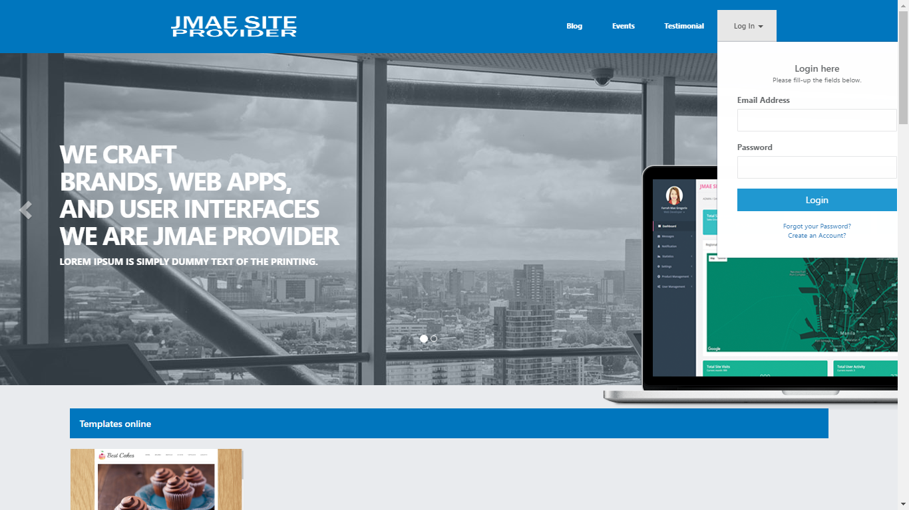

*Figure 4.9: Login Form*

You can create an account for you to allow to access some features of the website like commenting in blog and events post, and for purchasing the template/s. It has a verification code and sends it to your email, the purpose of this is to determine if the account is a bot or not.

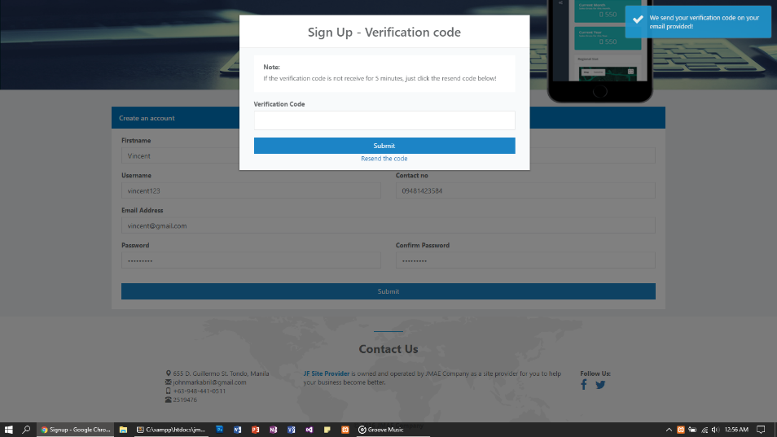

*Figure 4.10.1: Create an Account*

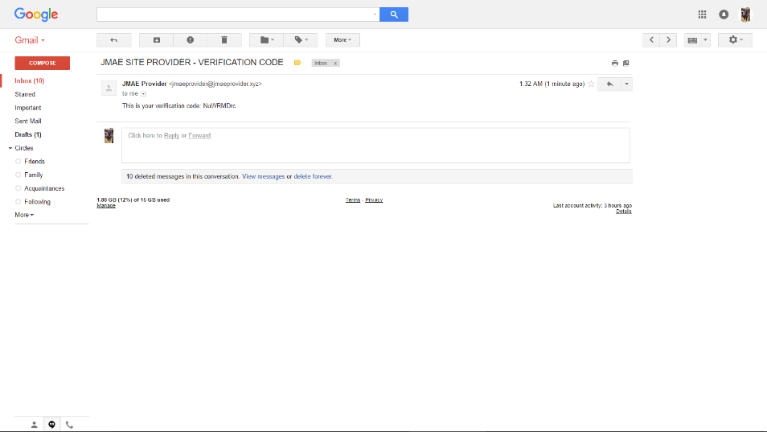

*Figure 4.10.2: Create an Account*

The administrator can monitor the total sales, last year sales, total templates, site visit and template sales of the year in graphical form for him to easy to identify. The administrator can also view the contacts that he/she have. The administrator has a small ToDo list, a simple reminder to him that he/she has a task the he/she need to accomplish. Issue tracker, where the user can send a report to the administrator that there is an error on his/her purchased template/s.

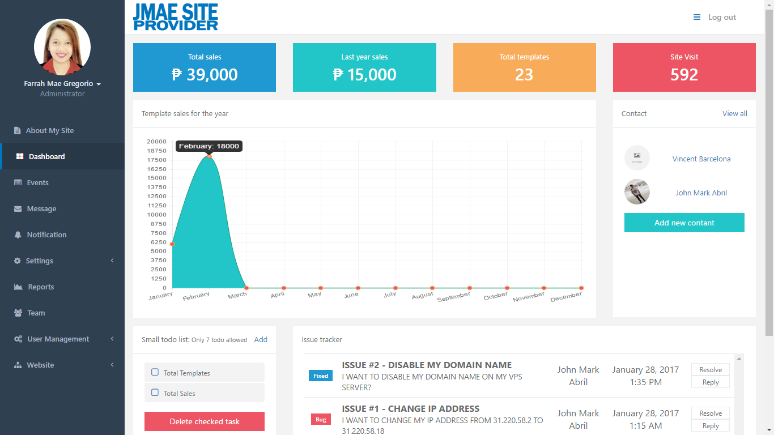

*Figure 4.11: Administrator – Dashboard*

The administrator can enable only one on his/her list of About My Site. About My Site, it is located in the footer of the website. Also, he/she can create, update, and delete a content for About My Site.

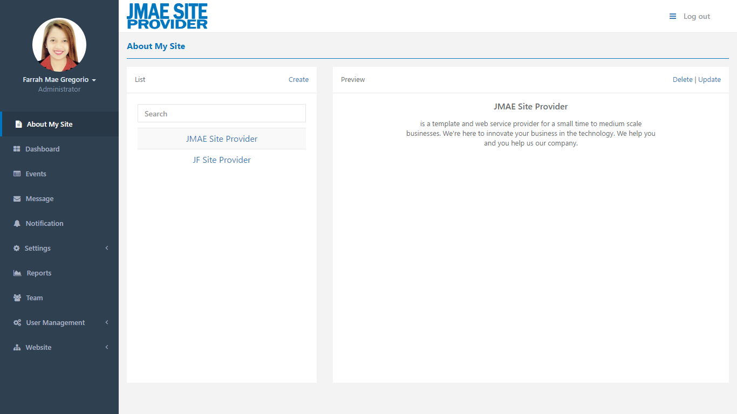

*Figure 4.12: Administrator – About My Site*

The administrator can create, update, and delete a content for Events. Events it is a simple announcement to the user if there is an upcoming event in their company.

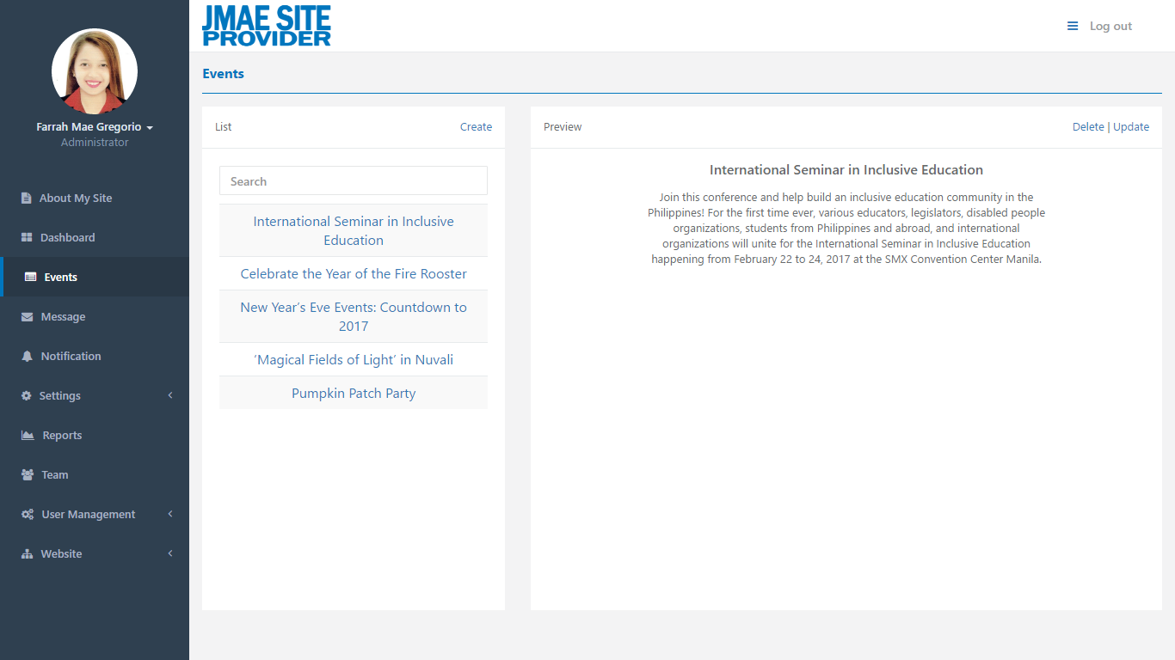

*Figure 4.13: Administrator – Events*

The administrator can compose a message and respond to the message that he/she receive. For the preview of the message and conversation just simply click the title of the message.

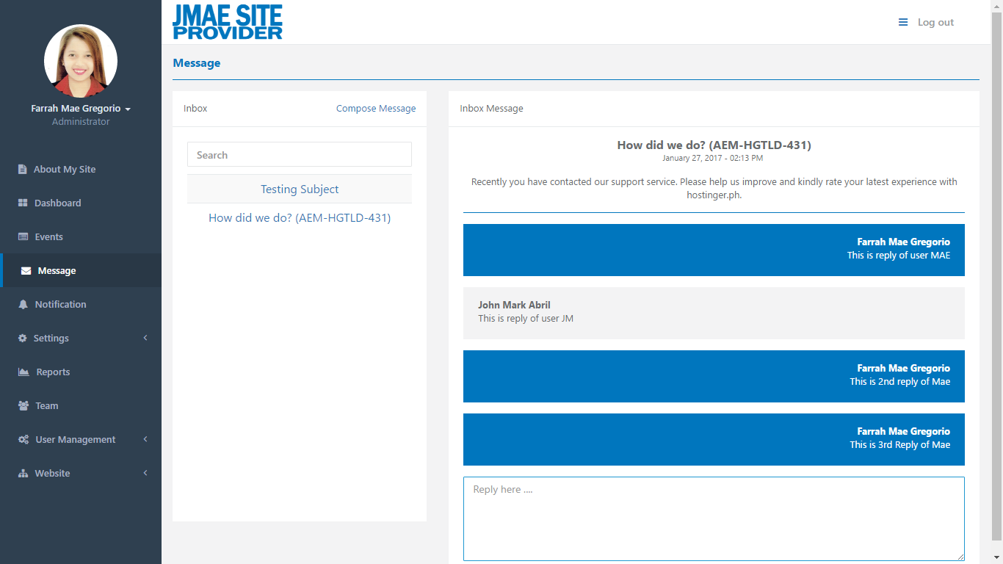

*Figure 4.14: Administrator – Message*

The administrator can monitor the user activity on their website.

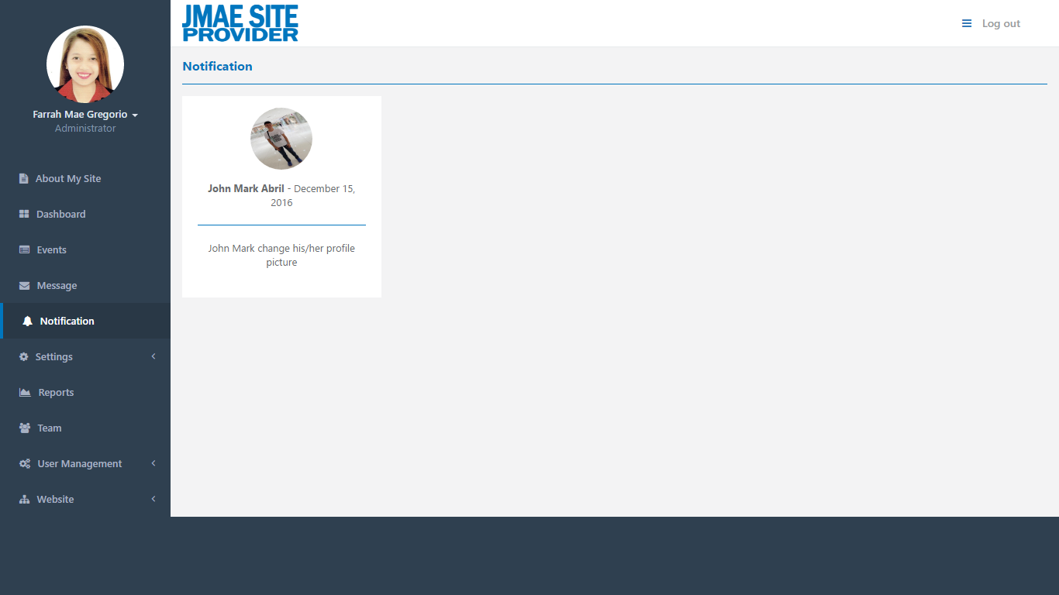

*Figure 4.15: Administrator – Notification*

In Settings, there is a PayPal Configuration where the administrator can manage the PayPal account on which account need to enable to handle the money. Also, the administrator can create, update and delete a PayPal account.

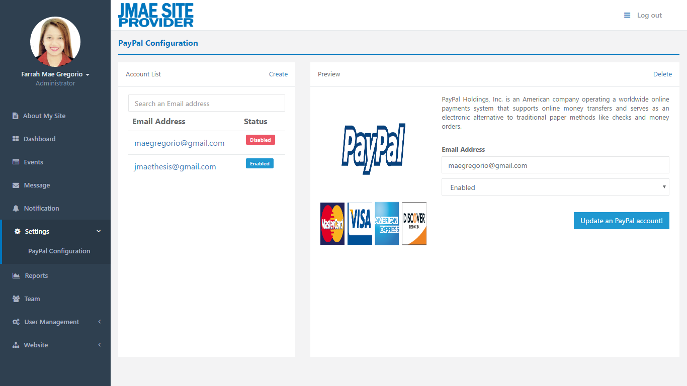

*Figure 4.16: Administrator – Settings*

The administrator can monitor the number of users, user activity, and sales report. The color green it represents for the current year and the color gray it represents for the previous year.

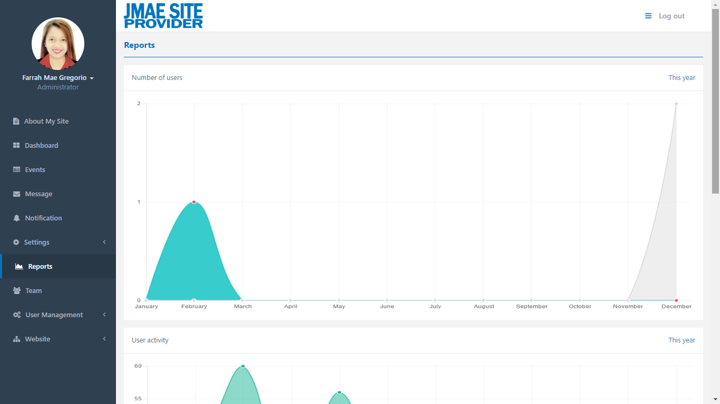

*Figure 4.17.1: Administrator – Reports*

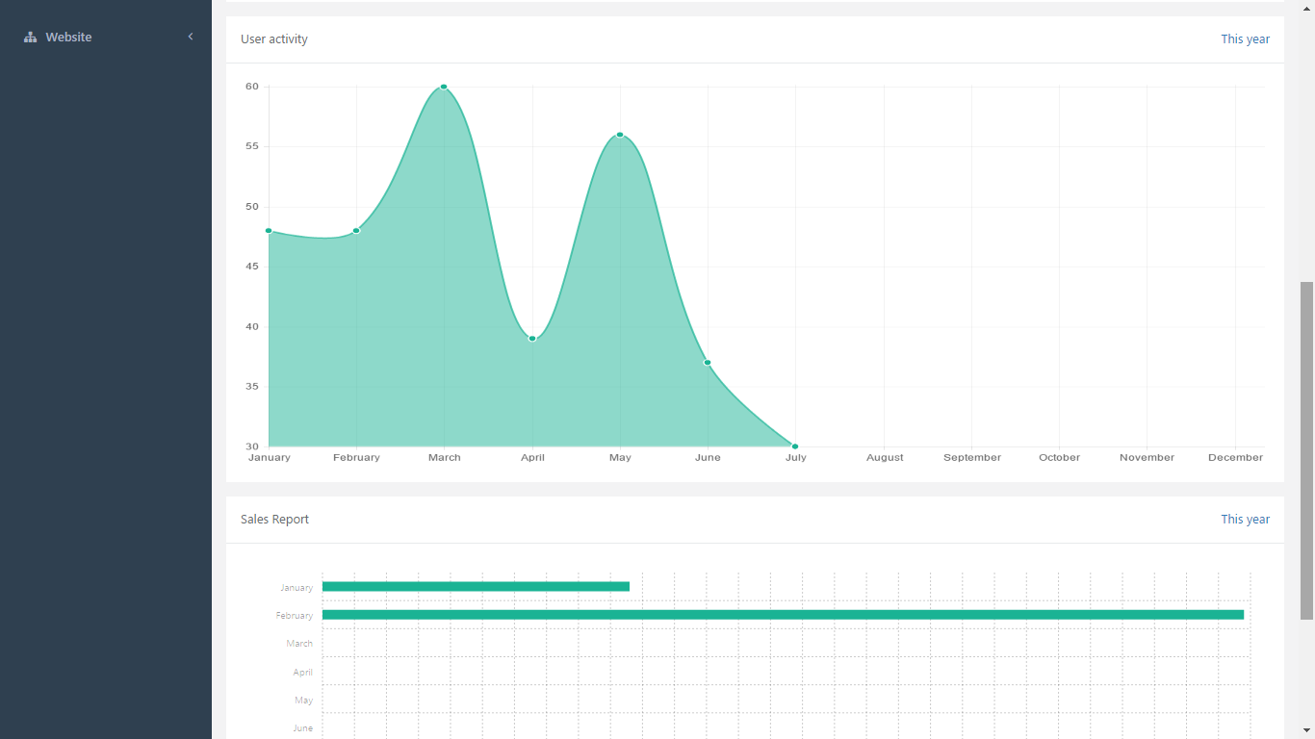

*Figure 4.17.2: Administrator – Reports*

The administrator can manage whose team he/she want to add. A sample of this is the people whose work on him.

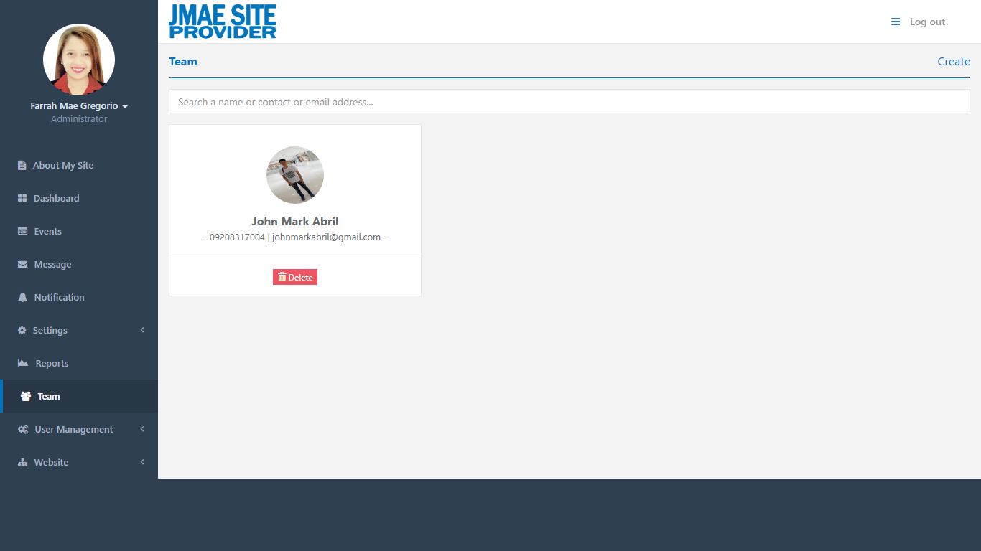

*Figure 4.18: Administrator – Team*

In User Management, there are three (3) categories: Account, Agent, and Co-Administrator. In the account, the administrator can monitor the total number of users and the total for the current month. In agent, the administrator can monitor the list of an agent that he/she have and, he/she can create, preview and delete an account of an agent. In co-administrator, the administrator can monitor the list of co-administrator he/she have and create, update, and delete an account of co-administrator. Also, the administrator can update the permission of co-administrator that he/she allowed accessing.

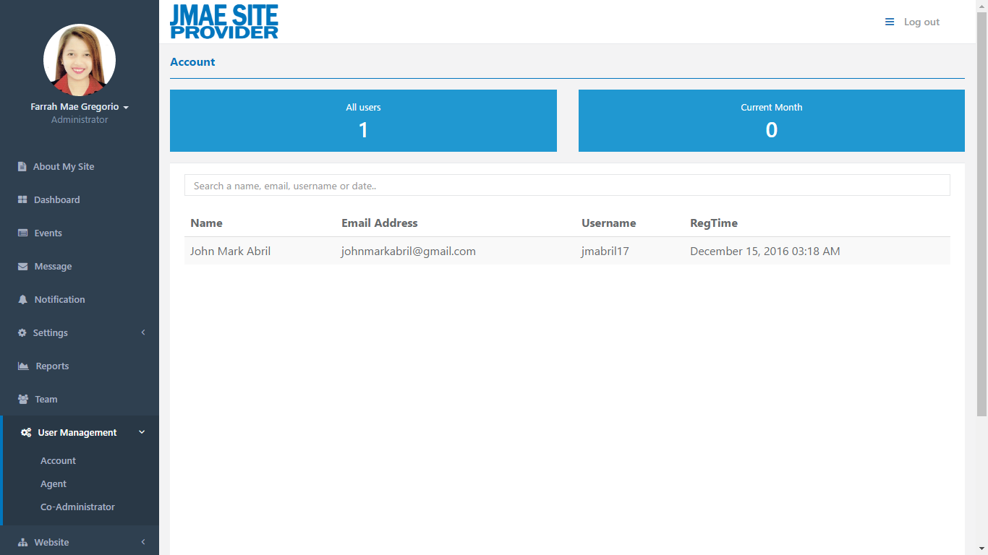

*Figure 4.19.1: Administrator – User Management*

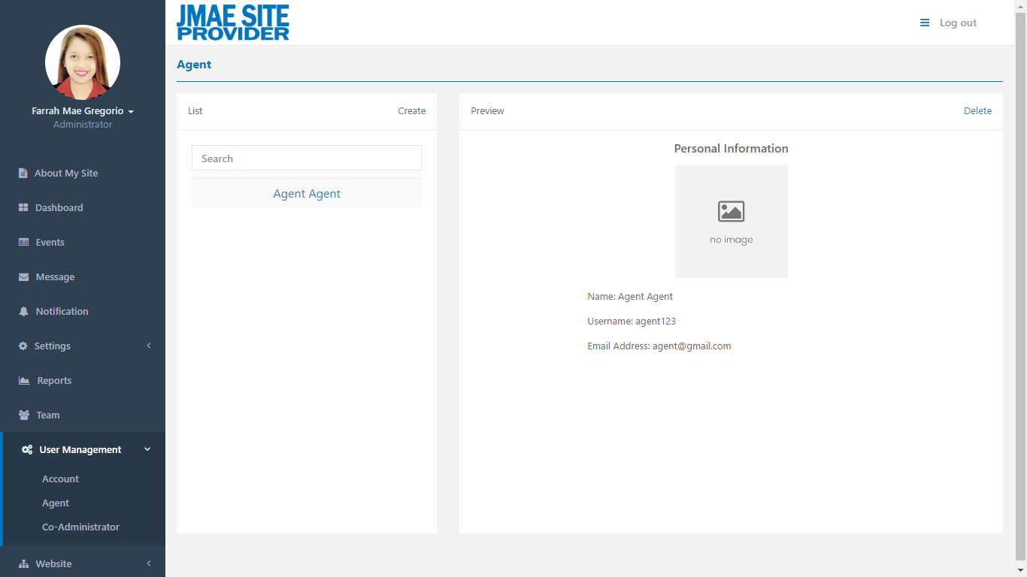

*Figure 4.19.2: Administrator – User Management*

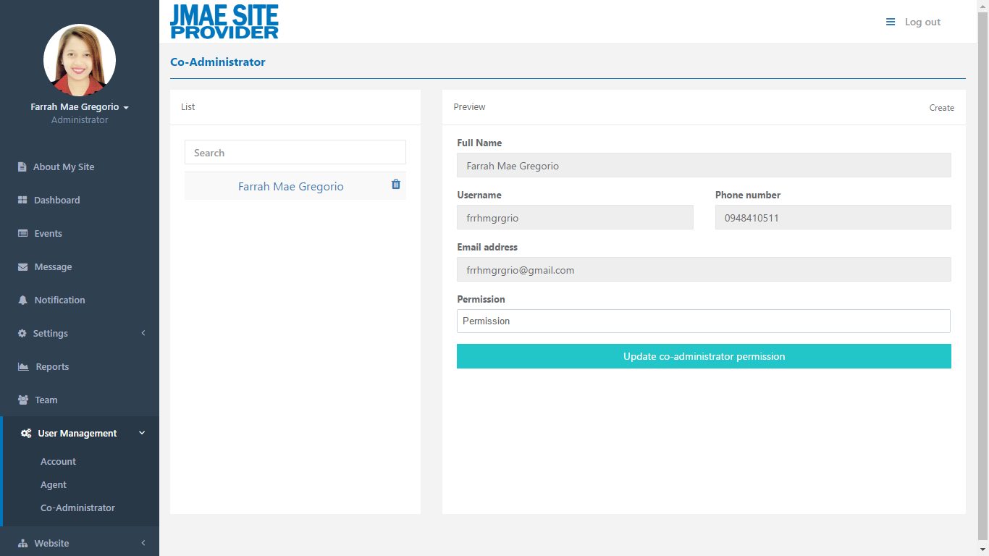

*Figure 4.19.3: Administrator – User Management*

In Website, there are two (2) categories: Website Online and Website Template. In website online, the administrator can monitor the templates that already rented by the client. In website template, where the templates are available to rent.

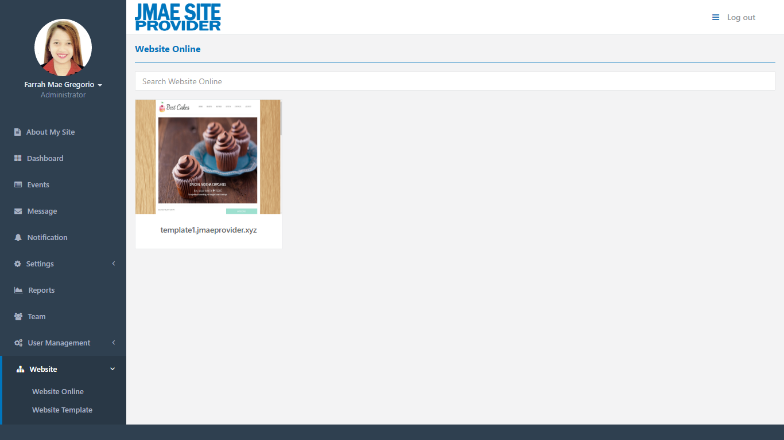

*Figure 4.20.1: Administrator – Website*

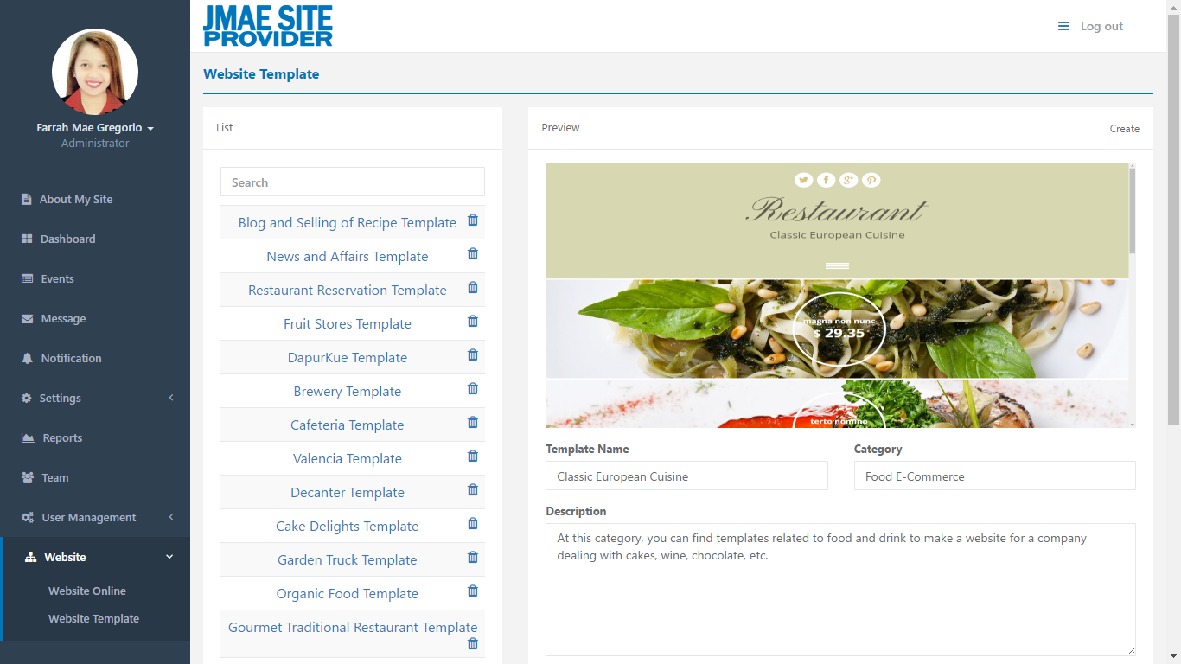

*Figure 4.20.2: Administrator – Website*

**4.3 Tabulating Results from the Proposed System**

**Project Evaluation**

The result of the respondent’s feedback to a given questions.